Steps and screenshots to connect to an Oracle Stored Procedure within BIRT 2.3.0

Create a new Data Source and select JDBC Data Source
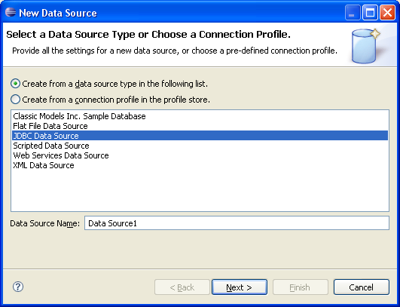

If you have not already added the Oracle JDBC drivers, use the Manage Drivers button to add the location of the JAR or ZIP file containing your JDBC drivers.
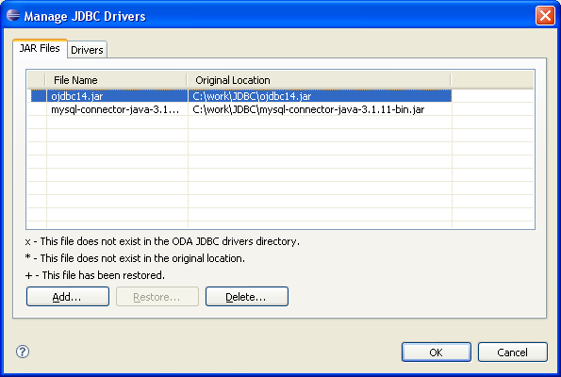

Select the Oracle Driver from the drop-down and fill out the URL, username, and password.
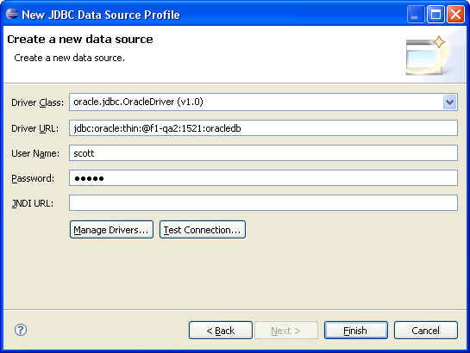

New Data Set – Select SQL Stored Procedure Query from the dropdown
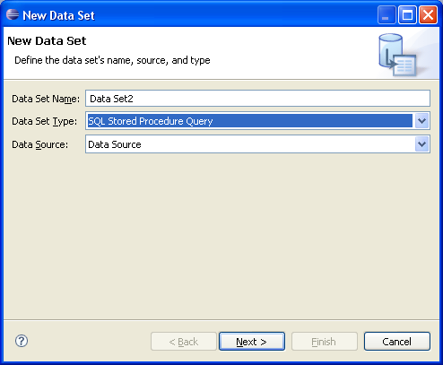

Select Stored Procedure – (They are easier to find if you apply the Stored Procedure filter.) You should see both the input and output parameters for your stored proc. Put a question mark for each output parameter/ref cursor, and put a valid value for any input parameters. This is just to get correct data returned initially and we can replace the hard coded values with parameters later.

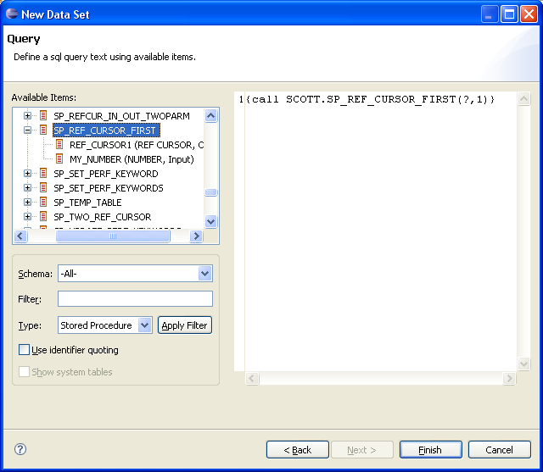

Press Finish and then Preview Results
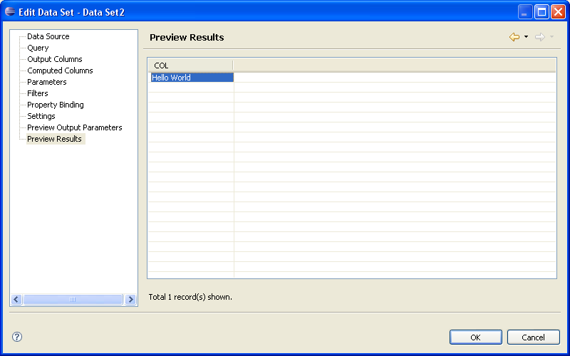

To remove the hard coded value, change the value to a question mark in the Query tab
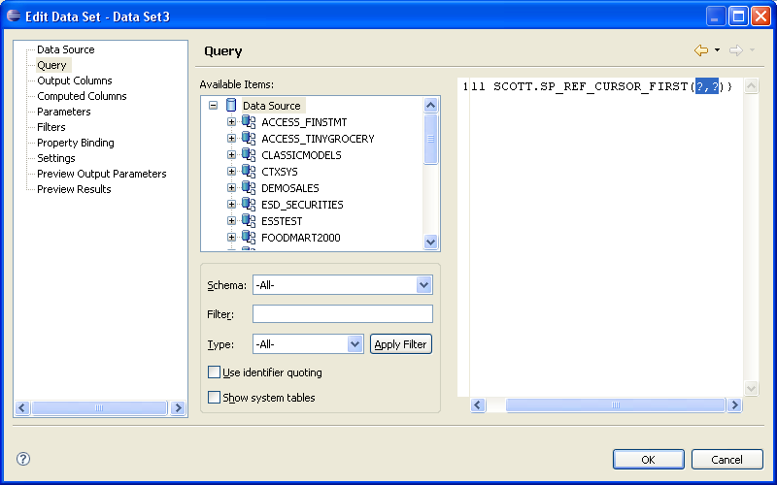

Select the Parameters tab
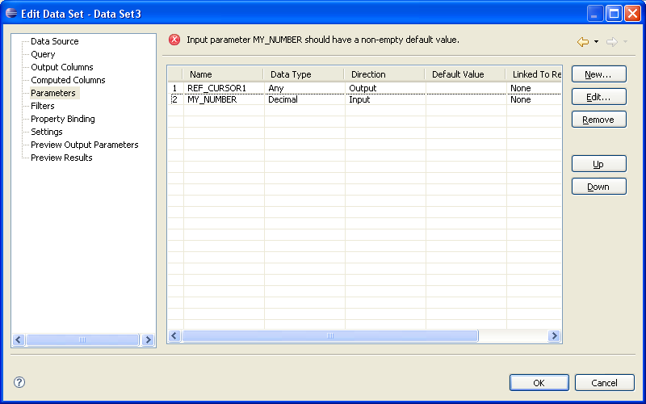

Enter a default value for the Input parameters
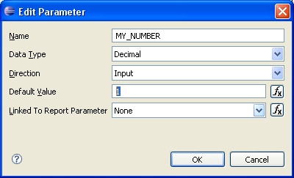

Optionally, if you want the user to pass in the parameter, press the Expression Builder [Function] button next to the Linked to Report Parameter to create a new parameter
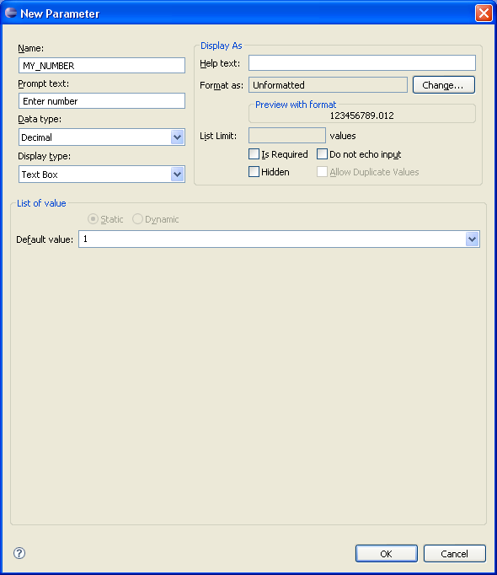

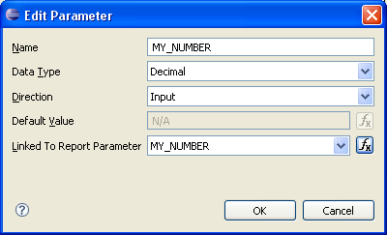

Press OK and you should now be able to use your new Data Set in your BIRT Report

